|  |
| --- |
| **CME 2203 Lab 5 Pre-lab**  **Name:**  **Student Number:**  **Session:**  **Subject:** Transistors |

☞ Please read this document from start to finish carefully before starting your work.

☞ Prepare as a report (in **PDF)** including screenshots and simulation graphs, error logs etc.

☞ Prelab report must be prepared INDIVIDUALLY.

**Simulation 1**

Draw the following circuit on LTSpice Schematics and save to a folder of your choice.

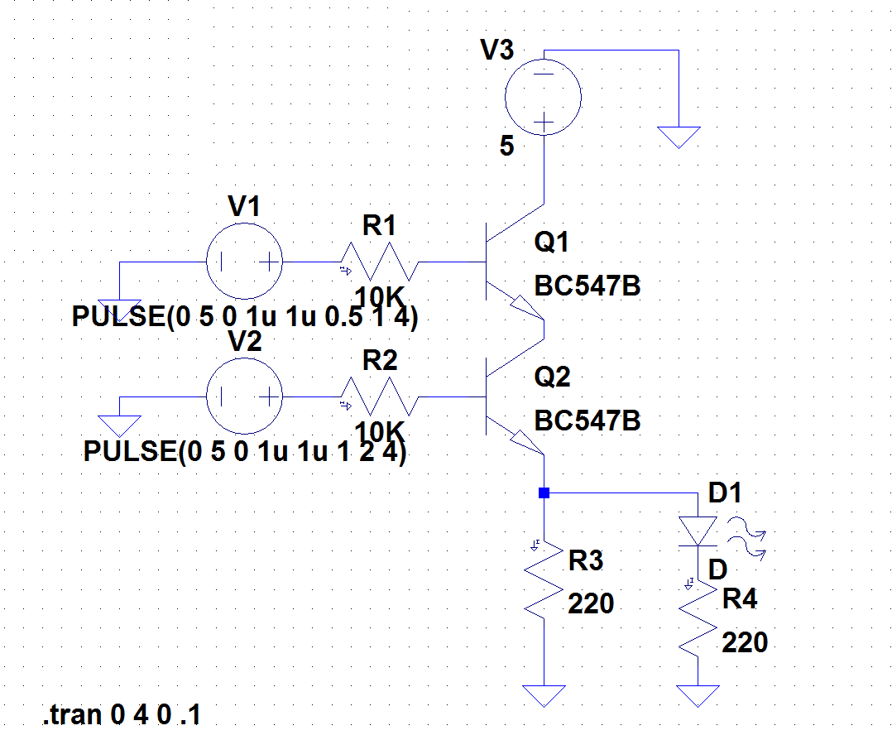

1. For each screenshot, top of the window should contain the graph plot panes, and the bottom of the window should contain:
   1. The circuit diagram
   2. The text label as in previous pre-labs
   3. The Spice Error Log (see instructions below on showing the error log)
2. Insert the following components on your circuit:
   1. Three voltage sources V1, V2 and V3
   2. Four resistors R1, R2, R3 and R4
   3. Five GNDs
   4. One LED
   5. Two NPN transistors Q1 and Q2
3. Adjust the component values as follows:
   1. For V3 we can just assign a DC value of +5V.
   2. We want V1 to act as a switch we open and close periodically as before, so we want it to produce a square wave voltage pattern. To achieve this, right click on V1 and click Advanced. Select PULSE. Enter the parameters as follows:
      1. Vinitial(V) : 0
      2. Von(V) : 5
      3. Tdelay(s) : 0
      4. Trise(s) : 1u
      5. Tfall(s) : 1u
      6. Ton(s) : 0.5
      7. Tperiod(s) : 1
      8. Ncycles : 4
   3. Same thing for V2, but we want it to have a longer period. Right click on V1 and click Advanced. Select PULSE. Change only the given parameters as follows (others are the same as V1):
      1. Ton(s) : 1
      2. Tperiod(s) : 2
   4. Set the resistor values to R1=R2=10KΩ, the resistor R3=220Ω and diode resistor R4 = 220 Ω
   5. For both Q1 and Q2, right click on the transistor. Click *Pick New Transistor*, and choose BC547B from the list. Click OK and close the dialog box (check you see BC547B on the circuit for both transistors).
   6. Finally, go to Tools\Color Preferences. Select the Waveform tab, and click on the background of the graph, you should see “Click to edit Background color” and pull the Red, Green and Blue sliders to 255 to make it White.
4. Now, we are ready to run the simulation! Click on the running man  and edit the simulation command (Remember, you can also change this command later by going to Simulate\Edit Simulation Command):
   1. Under the Transient tab, select the following parameters:
      1. Stop Time : 4
      2. Time to Start Saving Data : 0
      3. Maximum Timestep : 0.1 and click OK.

Click the running man again. You should see an empty graph on top of the window now. Let’s fill it with graphs!

* 1. Click the red probe appearing on the circuit to the wire connecting to positive side of V1 (node 2). Right click on V(n002) and change default color to blue to make it more visible against White background. This is logic input A.
  2. Now, move the cursor to the graph, right click and select Add Plot Pane. You should have a total of four plot panes. Click the red probe appearing on the circuit to the wire connecting to positive side of V2 (node 5). Right click on V2(n005) and change default color to blue to make it more visible against White background. This is logic input B.
  3. Now, move the cursor to the graph, right click and select Add Plot Pane. Click on the wire connecting to the positive side of the LED (node 4). Make its color blue as before. This is the logic output. Now you should have a total of three voltage plot panes.
  4. Now draw the current through the LED, so you should click exactly on the diode when you see the current meter symbol (a red arrow inside a black clamp). Again, make the trace color blue. So you should have a total of four panes on your graph.
  5. Finally, we want to view the Spice Error Log on the right side of the circuit. Go to View\SPICE Error Log and carry this window to the right side of the circuit. It should be visible on your screenshot. It should NOT block the graphs.

**Note**: You can choose different colors in the graphs as long as they are **VISIBLE(ex.white, yellow on black or black, blue on white. NOT blue on black or yellow on white)**.

Congratulations! You are all set! Now have some rest.

Also, please try to understand how these circuits work.